Dynamic Route

🧱 What Is Dynamic Route?
# Source: AI Source: Provided by: [Data Path: Persons Table -> ID Column: 1, Name_En Column: Motasem Essam] -> From: [ChatGPT] on [1/16/2026]
A dynamic route is a route that is automatically learned and updated by a router using routing protocols (e.g., RIP, OSPF, EIGRP, BGP). These protocols allow routers to exchange information, detect network changes, and recalculate the best paths without manual input.

🧠 Simple Definition:
# Source: AI Source: Provided by: [Data Path: Persons Table -> ID Column: 1, Name_En Column: Motasem Essam] -> From: [ChatGPT] on [1/16/2026]
A dynamic route is a path that routers learn automatically from other routers using routing protocols, and can adjust if the network changes.

🔄 Example Routing Protocols:
# Source: AI Source: Provided by: [Data Path: Persons Table -> ID Column: 1, Name_En Column: Motasem Essam] -> From: [ChatGPT] on [1/16/2026]
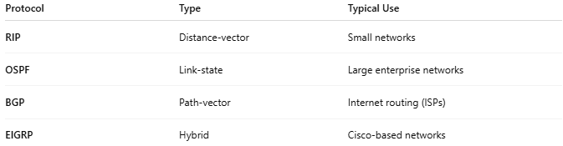
Protocol | Type | Typical Use
RIP | Distance-vector | Small networks
OSPF | Link-state | Large enterprise networks
BGP | Path-vector | Internet routing (ISPs)
EIGRP | Hybrid | Cisco-based networks

📦 What Happens in Dynamic Routing?
# Source: AI Source: Provided by: [Data Path: Persons Table -> ID Column: 1, Name_En Column: Motasem Essam] -> From: [ChatGPT] on [1/16/2026]
- Routers send updates to neighbors.
- They calculate the best path to every destination.
- If a link goes down, they automatically reroute traffic.

🧾 Sample Routing Table Entry (Dynamic)
# Source: AI Source: Provided by: [Data Path: Persons Table -> ID Column: 1, Name_En Column: Motasem Essam] -> From: [ChatGPT] on [1/16/2026]

Destination | Subnet Mask | Next Hop | Interface | Protocol
10.20.30.0 | 255.255.255.0 | 192.168.1.1 | eth0 | OSPF
🧠 This entry was learned dynamically via OSPF, not added manually.

🔍 Characteristics of Dynamic Routes:
# Source: AI Source: Provided by: [Data Path: Persons Table -> ID Column: 1, Name_En Column: Motasem Essam] -> From: [ChatGPT] on [1/16/2026]
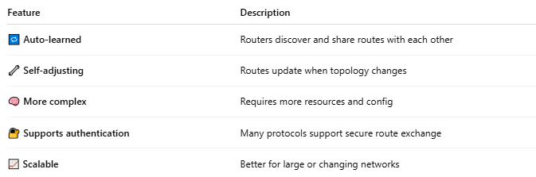
Feature | Description
🔁 Auto-learned | Routers discover and share routes with each other
🔧 Self-adjusting | Routes update when topology changes
🧠 More complex | Requires more resources and config
🔐 Supports authentication | Many protocols support secure route exchange
📈 Scalable | Better for large or changing networks

🆚 Static vs Dynamic Route
# Source: AI Source: Provided by: [Data Path: Persons Table -> ID Column: 1, Name_En Column: Motasem Essam] -> From: [ChatGPT] on [1/16/2026]
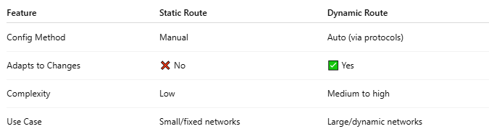
Feature | Static Route | Dynamic Route
Config Method | Manual | Auto (via protocols)
Adapts to Changes | ❌ No | ✅ Yes
Complexity | Low | Medium to high
Use Case | Small/fixed networks | Large/dynamic networks

✅ Summary
# Source: AI Source: Provided by: [Data Path: Persons Table -> ID Column: 1, Name_En Column: Motasem Essam] -> From: [ChatGPT] on [1/16/2026]

Attribute | Value
Type | Automatically learned
Set By | Routing protocols (e.g., OSPF, RIP)
Updates | Dynamically, based on network events
Best For | Medium to large, or changing networks

